Building the Model 90’s

Big Horn Armory was started with the idea to build premium, high-performance lever guns chambered in the powerful 500 S&W Magnum. This was done to fill an obvious gap in the firearms market for a quick handling, rapid firing rifle in the powerful S&W magnum cartridge. We spent a couple of years in this single minded effort, destroying our first efforts to convert Marlins to this task.
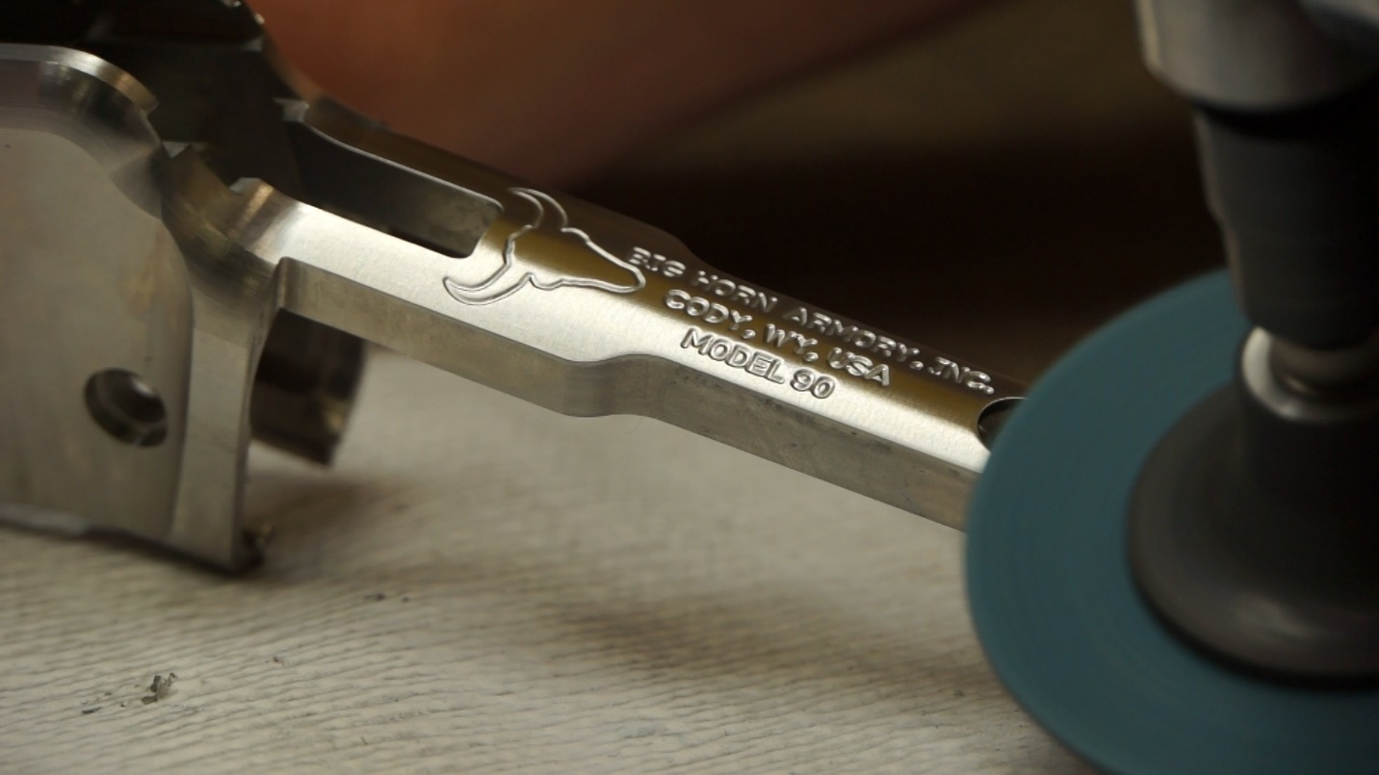

We realized it would be necessary to build our own action sized to the S&W revolver cartridges. Once we successfully completed this task, we focused on building the high quality guns you see today. This was no small effort, as there was very little knowledge to work with aside from a small nucleus of dedicated staff who were devoted to lever guns. We had to train people to build them properly while we were learning the best ways to make them function as well.
All the while, we had customers asking when we would add new chamberings. Mostly they were asking for the 460 S&W Magnum.
We had talked together early on about crafting a 460 lever gun and decided against it. It was a more difficult cartridge to feed through a lever gun because it is very long and skinny in relation to the 500 S&W. We had to modify the cartridge guides to allow the longer cartridge to release at the correct point. We also had to adjust spring pressures on the carrier higher to get the back of the cartridge to come up quicker and align with the chamber. The carrier also has to sit a little bit higher in relation to the receiver to account for the smaller cartridge diameter. A number of other parts require modification because of the skinnier cartridge.
The Model 90 is a more difficult gun to build and tune as a result of all this. Even today, the Model 90 take about twice as much time to run through our quality control builds. It is a much more finicky gun to get right than the Model 89.
Fortunately all of the development and required effort needed to make the Model 90 is worth it. The result is a finely tuned, high performance lever action rifle chambered in one of the highest velocity, 45 caliber cartridges available, the 460 Smith & Wesson Magnum.

