Building & Testing the AR500

The AR500 is a unique rifle. It is currently the most powerful production AR-type rifle in existence. While it has several unique features, it is essentially the same rifle that Eugene Stoner designed in the 1950s. It has the same features, like a direct gas impingement action, a non-reciprocating charging handle, a rotary locking bolt, etc.
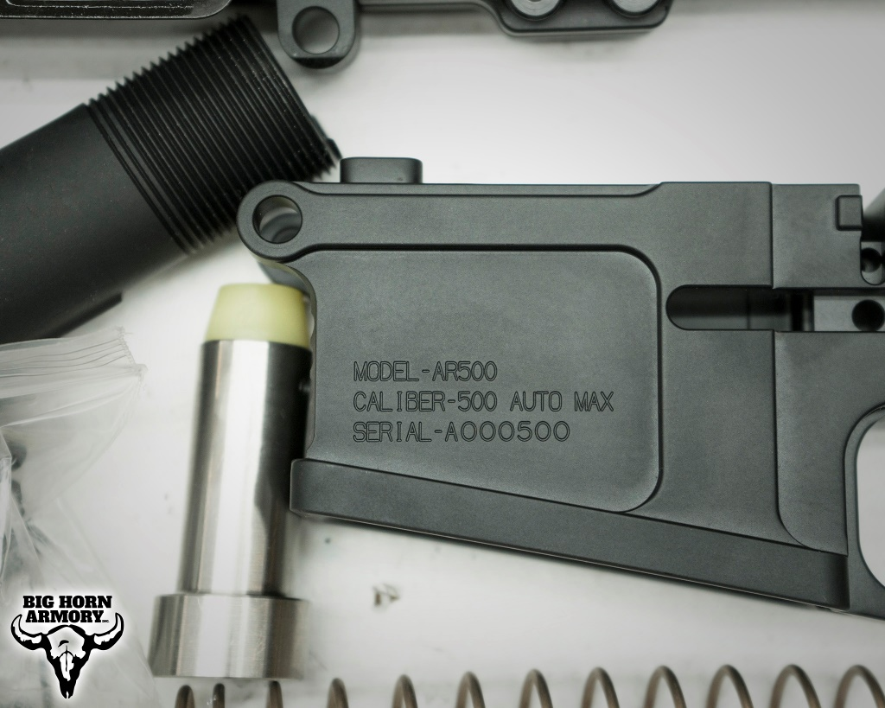
What it doesn’t share with Stoner’s AR10 is the cartridge. The 500 Auto Max is both larger in diameter, shorter in length, and more powerful in its ballistics. The differences pose some challenges in adapting the AR10 platform to this cartridge.
Big Horn Armory modifies the ejection port, the bolt face, and the extractor. This allows the cartridge to move through the feeding and ejection cycle. The magazine well is also reduced to AR15 mag dimensions, since the 500 Auto Max has the same overall length as a 5.56 NATO.
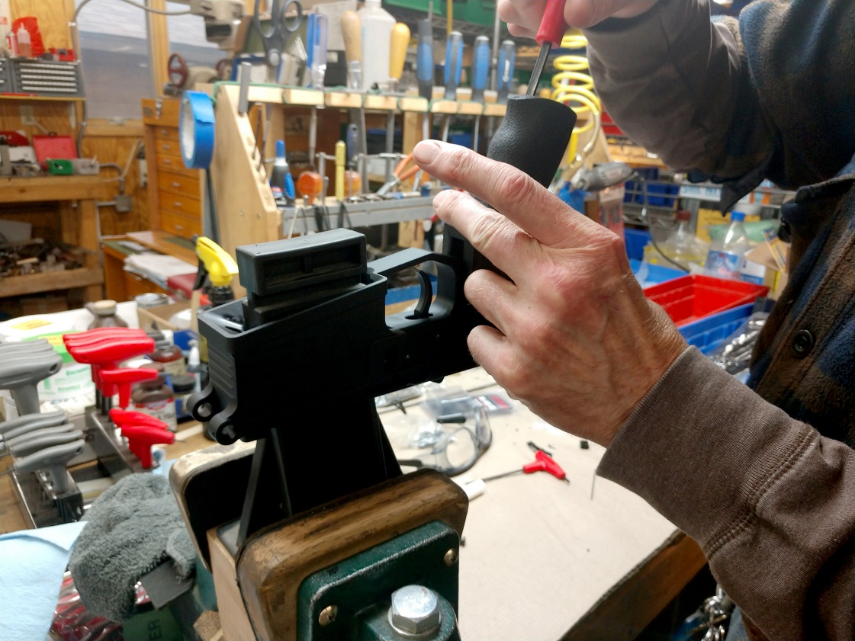
Once all of this is complete, the AR500 rifle build becomes just like building any other AR. You assemble the lower using all the required springs, pins, and other parts. We use a premium Rise Armament Drop-In Trigger, which specs out at a 4.5# pull weight for accuracy. We also use an ambidextrous safety selector. Our grip is an Ergo with a great texture and feel. Then, the buffer recoil spring and buffer weights are tuned to the heavier recoil impulse of the 500 Auto Max.
The upper is assembled using a 416 SS barrel chambered in 500 Auto Max and a specially modified barrel extension. Our bolt carrier group is coated to create a hard surface that is relatively impervious to wear and a slicker operating surface. This also generally reduces the amount of cleaning required. An adjustable gas block is used to allow for variation in loads or the use of a suppressor. Our handguard utilizes an M-LOK system to allow for easy addition of accessories and features a full-length extension of the Picatinny rail for additional sighting options.
Once all of these parts come together with proper lubrication, each rifle is hand cycled with dummy rounds to ensure proper feeding. Once this is satisfied, a full magazine of our test ammunition is fired through the rifle just to make sure everything is working correctly.
After this, each rifle is cleaned and re-lubed, and prepared for shipment, ready for the customer to punch holes in the toughest targets. We hope our customers enjoy the AR500 as much as we do.
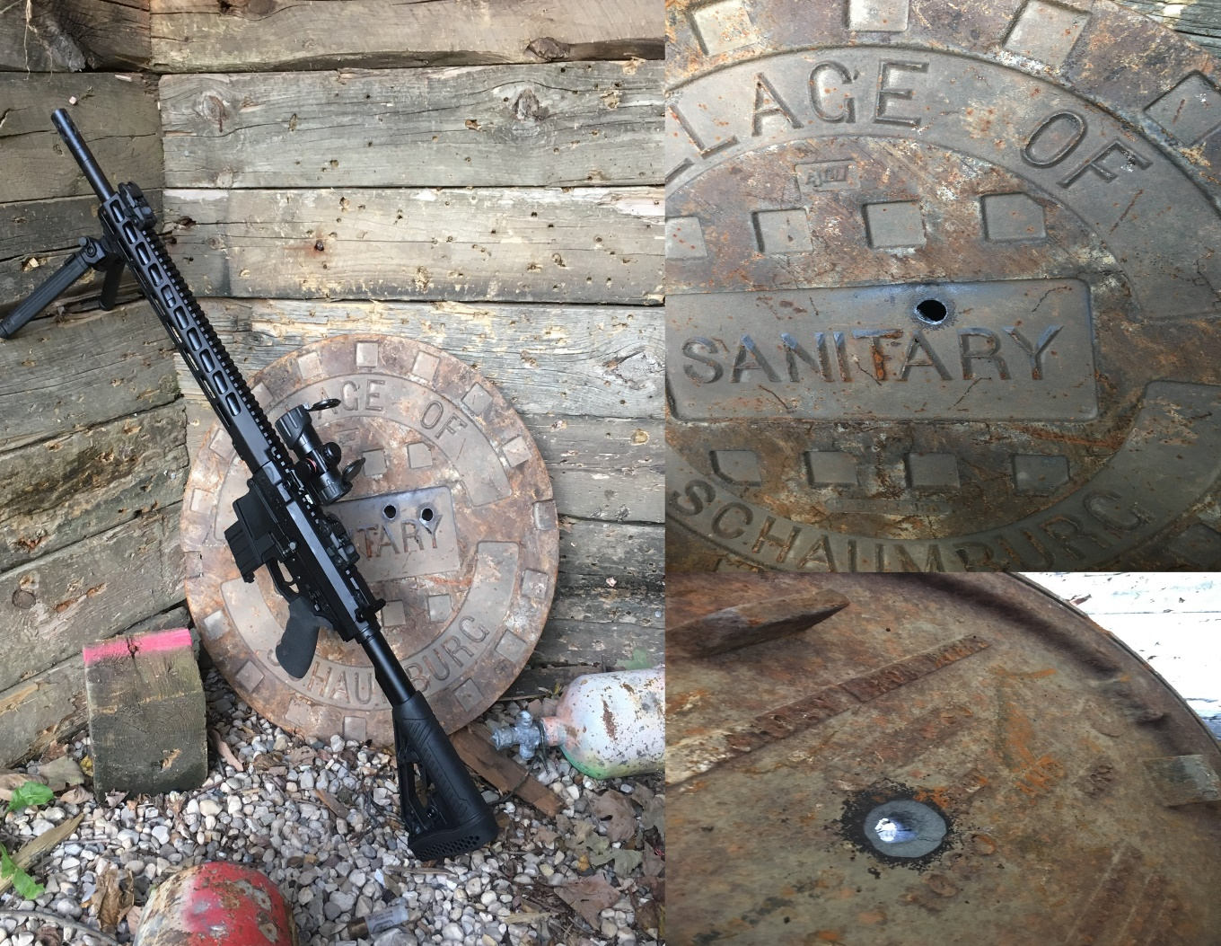

©2021 Big Horn Armory Inc.
www.bighornarmory.com

