How to use Point-Blank Range

Point-Blank Range is a term that everyone has heard of. Hollywood and the Main Stream Media often refer to it with the meaning of a distance where it is impossible to miss your target. Usually, they mean something like sticking a gun in a bad guy’s belly. While this is certainly within the limits of point-blank range, the term really means something quite different.
Point-blank range refers to a maximum range where the projectile will hit a target within a specific maximum deviation. Let’s say your target is a deer with its vitals contained within an eight-inch circle. The center point of that circle is four inches away from the edge. That means that if you aim at the circle’s center, you need to know the range at which the bullet’s trajectory will never vary more than four inches off-target. At this range, your bullet will always hit the vitals.
How do we calculate that range? First, you must understand that a bullet is subject to gravity from the instant that it leaves the muzzle of the barrel until it hits its target. That means that the bullet is always moving down while it is moving towards its target. Second, you must know at least three pieces of information. You must know the bullet’s ballistic coefficient, the velocity as it leaves the barrel, the wind speed and its direction.
All of this assumes that the gun is relatively horizontal to the target. Unless you are hunting in steep valleys, you needn’t worry about being 20 degrees or more off the horizontal and all of the following remains valid.
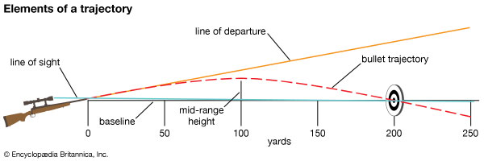
The line of sight is a direct, straight line from your eye through the sights of the gun to your target. This is usually an inch or so above the barrel centerline. However, the bullet is traveling downward after it leaves the barrel, so the barrel is pointed upwards relative to the line of sight. This means that the bullet which starts below the line of sight travels upward, crossing the line of sight to a high point above the line of sight, and then travels downward relative to the line of sight, eventually crossing below the line of sight.
For the deer vitals target, what we want to know is the maximum range where the bullet never travels more than four inches above or below the line of sight. This is the point-blank range.
The easy way to determine the maximum point-blank range is to use a ballistics calculator, plugging in the bullet’s ballistic coefficient, muzzle velocity, and wind speed and direction. Most ballistic calculators have several other inputs, like drag coefficient, altitude, barometric pressure, humidity, and temperature. These come into play when shooting at longer ranges, but since we are concerned with normal hunting distances of around 200 yards or less here, we can effectively ignore them.
A good online ballistics calculator can be found at:
http://www.shooterscalculator.com/ballistic-trajectory-chart.php
Once you have chosen a calculator, enter the required inputs and set the range step size as small as five yards, if possible. This allows you to see at what range the maximum heights, above and below the line of sight occur, and allow you to adjust the zero of your sights to get to the maximum point-blank range.
My favorite hunting load for a Model 89 is a 450gr Hard Cast Keith style bullet with a ballistic coefficient of .181 and a muzzle velocity in my gun of 2005 fps. If I set the zero at 150 yards I get a maximum height of 2.76” above the line of sight at 85 yards and a maximum height below 183 yards. See chart below for variations.
 |  |  |  | Maximum Point-Blank Range
Sight Zero Range | Max Elev. Above Line Of Sight in. | High Elev .Range yds | Max Elev. Below Line Of Sight in. | Low Elev. Range yds
150 | 2.76 | 85 | 4.00 | 183
155 | 3.03 | 90 | 4.00 | 187
160 | 3.32 | 95 | 4.00 | 192
165 | 3.63 | 95 | 4.00 | 195
170 | 3.95 | 95 | 4.00 | 198

You can see that changing the zero of your rifle sights affects the maximum Point-Blank Range. I have my personal Model 89 zeroed at 150 yards for a 183-yard Maximum Point-Blank Range with this load. With this setup, I can hold on to the same point for deer within 183 yards and be assured that the bullet will hit in the vitals if I do my part.

©2021 Big Horn Armory Inc.
www.bighornarmory.com

