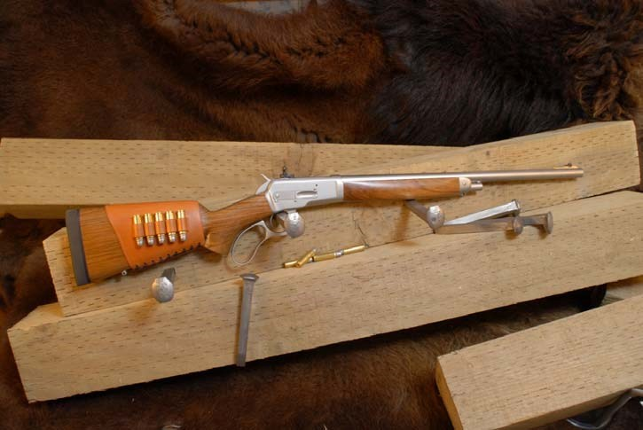

Model 90 SpikeDriver™

.460 S&W Magnum
Carbine and Rifle Models
Owner’s Manual

If you have any questions about the safe use of a Big Horn Armory firearm, call us at 307-586-3700 or write us at P.O. Box 940, Cody Wyoming 82414.
Via internet www.bighornarmory.com.
Copyright 2020 Rev 2

BIG HORN ARMORY

Owner’s Manual for Model 90 Carbine and Rifle models
Thank you for purchasing a Big Horn Armory firearm. With reasonable care, this firearm will provide many years of reliable service. Please read the following information carefully.

Use only the ammunition/caliber as listed on the barrel. Use of ammunition for which this firearm was not designed and intended may cause injury or death and will void the warranty.

It is essential that you read this entire manual before handling or using this firearm. If you do not understand anything in this manual, please contact Big Horn Armory or a certified firearms instructor, before handling or using this firearm.

Lever action firearms are by design, meant to function best with cartridges that are designed specifically for this type of action. Some standard factory loaded cartridges may not cycle/function correctly in this firearm. This is not a defect, merely a consequence of the lever gun design. If you are not certain whether a cartridge will function in this firearm, please contact the ammunition manufacturer or Big Horn Armory, Inc before using that cartridge.

Use only cartridges that are designed for tubular magazines. Use of pointed bullets or bullets with tips that can touch the primer directly may cause the entire magazine full of cartridges to fire at once. This event must be avoided as it may cause personal injury or death. It may also cause severe damage to the firearm. Such damage will not be covered under the warranty.

Big Horn Armory, Inc. recommends that only standard factory loaded ammunition designed for tube magazine, lever action guns be used in this firearm. Use of reloads, hand loads or other non-standard or non-factory loaded ammunition can be dangerous and will void the warranty for this firearm.

Maximum cartridge length for this firearm is 2.29”. Use of cartridges longer than this maximum length may cause malfunctions and possibly dangerous conditions. This may result in personal injury or death. Do not use cartridges longer than 2.29” under any circumstances.

FIREARMS SAFETY - The Four Essential Rules!

- Every firearm is always loaded!!! To assume otherwise can have fatal consequences.
- Never point a firearm at anything you are not willing to destroy. Constant muzzle awareness is essential to safe gun handling. Always keep muzzle pointed in a safe direction.
- Keep your finger off the trigger until you are on target and ready to shoot.
- Be sure of your target and beyond before you shoot, being mindful of a safety zone for shot fall or bullet ricochets and drop.

SAFETY INSTRUCTIONS
Always follow these rules for your safety and the safety of others:
- Always handle your gun as if it were loaded.
- Never take anyone’s word that a gun is unloaded.
- Always make sure that your gun is not loaded before laying it down or handing it to another person. Never leave a loaded firearm unattended.
- Never use alcohol or drugs before or during shooting.
- Always wear safety glasses and hearing protection when shooting.
- Never load a firearm without first making sure the bore, action and chamber are clean and free of obstructions.
- Use only clean, dry, factory ammunition matching the cartridge shown on the barrel for your gun.
- Never point your gun at anything you don’t intend to shoot.
- Keep your finger off the trigger until your sights are on the target.
- Always be absolutely sure of your target and the area beyond it before you pull the trigger. Never shoot at water or a hard surface.
- Be aware of the direction of your ejected cases.
- If you experience a round that fails to fire, keep the firearm pointed toward the target or in a safe direction for at least 30 seconds before opening the action.
- Never climb a tree or a fence or enter a blind with a loaded firearm. Never pull a loaded firearm towards you by the muzzle.
- Always make sure your shotgun is unloaded before cleaning, storing, or transporting it in a vehicle.
- Shooting or cleaning firearms can expose you to lead. Always wash hands thoroughly after use. Take protective measures to avoid contact or exposure to lead or chemicals.
- Never alter or modify this firearm.
- Always keep this manual with the firearm.

AMMUNITION ADVISORY
Big Horn Armory, Inc., specifically disclaims responsibility for any damage, injury or death resulting from the use of faulty, non-standard, remanufactured, reloaded, or hand loaded ammunition in this firearm.
We have found that there are a couple of manufacturer's loadings that are dangerous in a tube magazine gun. They will work flawlessly in a revolver, but are not for use in tube magazine guns. The following is a list of loads that should not be used:
Buffalo Bore | 26C | 275gr
CorBon | HT460SW275 | 275gr
Federal | P460XB1 | 275gr

All of these have bullets that are too sharply pointed. The bullet tip fits within the primer and could/would cause the entire magazine of rounds to fire inside the tube. There may be other loads that we have not seen which also have these characteristics. It is always best to double check your ammo.

While .454 Casull and .45 Colt ammunition will chamber and fire in the Model 90, this ammunition is not always long enough to feed correctly. Users who wish to regularly shoot this ammunition are advised to purchase the Model 90A, which is tuned specifically for these rounds.

Additionally, we would like to advise users of the Model 90 that Hornady 200gr SST Lever Revolution and Federal Fusion 260gr bullets may cause inconsistent feeding into the chamber. We have noticed that sometimes the soft tip catches in the gap between the case and the primer on the next cartridge in the magazine. Federal & Hornady’s products are first rate, but these just doesn’t always work well in our guns.

We recommend the use of Buffalo Bore loads 26A and 26B. These are perfectly suited to lever guns such as the Model 90. We use them in testing our guns and find that they feed and cycle very well.

Break In
Your firearm is newly manufactured in the USA from the best materials. We have taken the time and effort to work the action to ensure proper cycling. It may require a break in period of firing a number of rounds to reach a level of smoothness in the action. As always, the more the action is cycled, the smoother it will get.

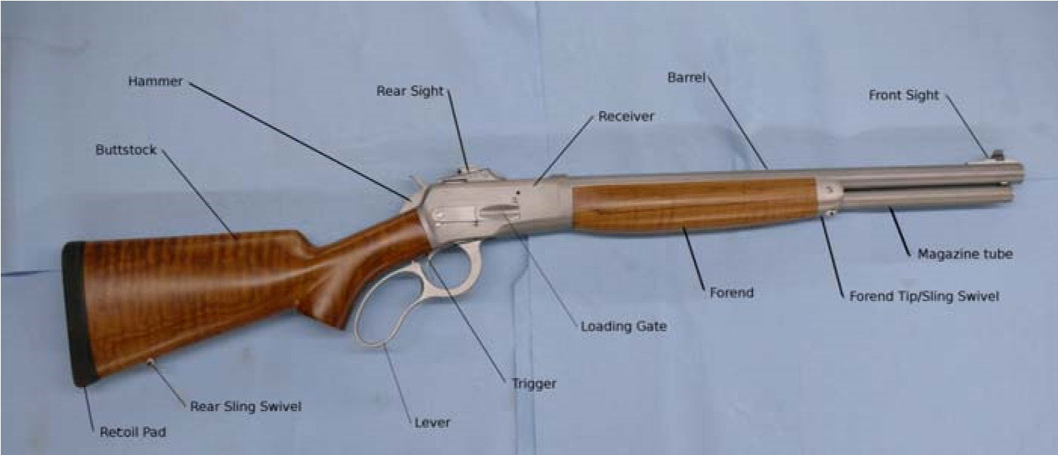

BEFORE USING YOUR FIREARM FOR THE FIRST TIME
Completely read and understand this manual. Learn how your firearm operates.
Familiarize yourself with its components and features. Before using your firearm, clean the inside of the barrel using light gun oil, following the cleaning procedure outlined later in this manual.

Be certain to move the lever fully in both directions when cycling the action. Failure to do the complete motion can cause a malfunction.

Loading
Point the muzzle in a safe direction. Insert cartridge bullet end first into the Loading Gate and push in until Loading Gate snaps shut. Repeat until magazine is full, Use of different length cartridges may affect how many cartridges the magazine will hold.

Unloading
Point the muzzle in a safe direction. Move the lever forward until any cartridge loaded in the chamber is ejected and the next cartridge is staged on the carrier. Move the Lever backwards until the cartridge is loaded into the chamber. Move the Lever forward until the previous loaded cartridge is ejected. Continue this process until you no longer observe a cartridge in the chamber or on the carrier.

Half cock
Point the muzzle in a safe direction. Draw the Hammer slowly backwards slightly until you hear and feel a click. This will be the half cock position and will keep the Hammer from contacting the Firing Pin during normal operation. Depressing the Trigger should not cause the Hammer to drop on the Firing Pin.

Full cock
Point the muzzle in a safe direction. Draw the hammer back fully until you hear and feel a second click. This will be the full cock position. The Hammer will normally be in this position after cycling the lever fully. Depressing the Trigger will cause the Hammer to drop on the Firing Pin and fire the gun.

Uncock
Point the muzzle in a safe direction. Place a finger on the ridges at the back of the Hammer and hold firmly while depressing the Trigger. Slowly allow the hammer to return to the down position, gently touching the Firing Pin.

WARNING
DO NOT DISASSEMBLE THIS FIREARM. This firearm is carefully assembled at the factory by trained technicians. It is not necessary to disassemble this firearm to clean or lubricate it. Disassembly by other than a qualified gunsmith may cause damage to the working mechanism, which may in turn, cause malfunctions. Malfunctions may cause bodily injury or death. Damage to the working mechanism caused by disassembly will void the warranty.

WARNING!
Do not alter or modify the trigger or firing mechanism.

LUBRICATION AND CARE
WARNING!
Never clean or lubricate your gun unless it is completely unloaded.

Though manufactured with high quality, wear-resistant steel alloys, all bearing surfaces on the Model 90 Carbine and Rifle versions must receive a thin application of good quality firearm lubricant to function smoothly and decrease wear. The bolt, locking bolts, lever pin all require proper lubrication (see illustration). A thin layer is all that is needed.
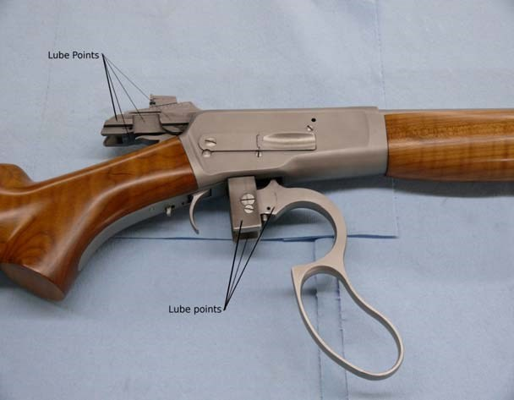
Make sure your firearm is unloaded prior to cleaning. To clean the bores after shooting, insert brushes and patches into the barrels from the muzzle end, applying solvent and oil as needed. Use of a crown protector is highly recommended to avoid damage to the crown which may affect the accuracy of your firearm. After cleaning, swab bore with a light film of a high quality gun oil, and wipe down all exterior metal with a treated gun cloth. The stock and forearm can be periodically waxed with a good quality carnauba wax, keeping the wax away from the checkering.

WARRANTY REPAIR
Our firearms are warranted for two years against materials and manufacturing defects. If for any reason you think your Big Horn Armory firearm is not functioning as described in this manual or otherwise not functioning properly, please contact us at 307- 5863700 or write us at PO Box 940, Cody WY 82414. (general@bighornarmory.com). If repairs are necessary, our service department will issue a Return Authorization number. Once the firearm is received, we will evaluate the firearm to determine the best course of action. Abuse of the firearm or use of non-factory ammunition voids the warranty.

IMPLIED WARRANTY

Any implied warranties, including the implied warranties of merchant ability and fitness for a particular purpose, are limited to a 90 day duration from date of original retail purchase. Limitations regarding implied warranties vary by state, so the above limitation may or may not apply. Any provision of this warranty prohibited by federal, state, or municipal statute, which cannot be pre-empted, is not applicable.

Big Horn Armory, Inc., PO Box 940, Cody WY, 82414.
Phone: 307-586-3700. Fax: 307-586-3701.
(general@bighornarmory.com)
Copyright 2020 Rev 2

